Genesis 1 & 2 June 17, 2018
He Was in the Beginning, Part 2 (Creation)
Rev. Meagan Boozer

Last week we started our summer sermon series entitled “He Was in the Beginning.” We are looking for Jesus in the first book of the Bible – the book of Genesis. We started last week in Luke 24 when Jesus came to the two followers on the road to Emmaus and explained who he was using all the Scriptures. We read in that account how the disciples’ hearts were burning inside of them as he opened the Scriptures to them in this way. What if we were able to do that? What if, when we encounter people who are doubting that Jesus really is the saving Son of the One True God, what if we could open the Scriptures in a way that causes their hearts to be warmed as they yearn for more? Finding Jesus in Genesis is a great place to start. Let’s pray:
Holy and Everlasting God, renewing and refreshing God, creating and restoring God, thank you that you are mindful of us. Thank you that your love is so great for us that you didn’t just create us then leave us alone. Thank you that you gave us minds to think, and hearts to love, and souls that yearn for you and your presence. Help us now to hear your truth anew that makes a difference in how we live and how we love. This we pray in Jesus’ name, Amen.
I think it is best if we just begin by opening up the Scriptures. We are looking and listening for Jesus, who was in the beginning. We are looking for confirmation that Jesus was not ‘Plan B’ to save humanity. Jesus was always the plan.
- Genesis 1:1-3, “In the beginning when God created the heavens and the earth, ² the earth was a formless void and darkness covered the face of the deep, while a wind from God swept over the face of the waters. ³ Then God said, “Let there be light”; and there was light.”
- John 1:1-5, “In the beginning was the Word, and the Word was with God, and the Word was God. ² He was in the beginning with God. ³ All things came into being through him, and without him not one thing came into being. What has come into being ⁴ in him was life, and the life was the light of all people. ⁵ The light shines in the darkness, and the darkness did not overcome it.”
- John 8:12, “Again Jesus spoke to them, saying, “I am the light of the world. Whoever follows me will never walk in darkness but will have the light of life.”
- Colossians 1:11-17, “ May you be made strong with all the strength that comes from his glorious power, and may you be prepared to endure everything with patience, while joyfully ¹² giving thanks to the Father, who has enabled you to share in the inheritance of the saints in the light. ¹³ He has rescued us from the power of darkness and transferred us into the kingdom of his beloved Son, ¹⁴ in whom we have redemption, the forgiveness of sins. ¹⁵ He is the image of the invisible God, the firstborn of all creation; ¹⁶ for in him all things in heaven and on earth were created, things visible and invisible, whether thrones or dominions or rulers or powers—all things have been created through him and for him. ¹⁷ He himself is before all things, and in^{[i]} him all things hold together.”
- 2 Timothy 1:8-10, “Do not be ashamed, then, of the testimony about our Lord or of me his prisoner, but join with me in suffering for the gospel, relying on the power of God, ⁹ who saved us and called us with a holy calling, not according to our works but according to his own purpose and grace. This grace was given to us in Christ Jesus before the ages began, ¹⁰ but it has now been revealed through the appearing of our Savior Christ Jesus, who abolished death and brought life and immortality to light through the gospel.”
- Hebrews 1:1-3a, “ Long ago, at many times and in many ways, God spoke to our fathers by the prophets, ² but in these last days he has spoken to us by his Son, whom he appointed the heir of all things, through whom also he created the world. ³ He is the radiance of the glory of God and the exact imprint of his nature, and he upholds the universe by the word of his power.
- Jude 24, “ Now to him who is able to keep you from falling, and to make you stand without blemish in the presence of his glory with rejoicing, ²⁵ to the only God our Savior, through Jesus Christ our Lord, be glory, majesty, power, and authority, before all time and now and forever.”
- Revelation 21:22-23, “I saw no temple in the city, for its temple is the Lord God the Almighty and the Lamb. ²³ And the city has no need of sun or moon to shine on it, for the glory of God is its light, and its lamp is the Lamb.”

Let’s first establish this truth: God is one, yet God is three. God is one God, but God is also Father, Son, and Holy Spirit. When we describe the nature of God we use the word ‘Being.’ John 4:24 declares, “God is Spirit.” God is unlike any other being. God is the God-being, just as we are the human-beings. God is the God-being as one, but there are three whos within the one being of God – what we call the God-head, or the Trinity, or the three divine persons – Father, Son, and Holy Spirit. One person in the Godhead (of 3) did not exist before the others, or without the others, and neither is one person inferior to the others. Kick the old picture of the triangle representing the Trinity out of your minds (now that I just put it back in there, haha), because it implies a hierarchy which is not biblical. Use a circle instead to represent the fullness of equal communion between the Father, Son, & Holy Spirit.

Why do we need a refresher on the Doctrine of the Trinity? Because it is important for us to establish this fact: Just as God the Father has always been, Jesus has always been, and the Holy Spirit has always been. They have different roles for their restoring work in our lives, but they are never without the communion of the others. The full communion of God - Father, Son, and Holy Spirit has always been and forever will be.
I think it helps us to understand the creation account when we know that the first words of Genesis in Hebrew are not, “In the beginning,” but “In beginning.” In beginning, God (Father, Son, & Holy Spirit) created the heavens and the earth. It shows a pre-existence, doesn’t it? It’s like if someone decides to build a house. They were there before the house started, they decided to start it, and in beginning, they started it.
In beginning, God the Father, God the Son, and God the Holy Spirit formed the heavens and the earth out of nothing. Out of nothing, ex nihilo, the heavens and the earth were created. But in reading the Scriptures we just read, Jesus definitely seems to be a focal point in all of this, doesn’t he? From John 1, “All things came into being through him, and without him not one thing came into being.” From Colossians 1, “…for in him all things in heaven and on earth were created, things visible and invisible, whether thrones or dominions or rulers or powers—all things have been created through him and for him. ¹⁷ He himself is before all things, and in him all things hold together.” It seems that Jesus wasn’t just there in beginning, Jesus was the motivation behind the creation of the heavens and the earth and everything in them! “All things have been created through him and for him.” Why? Because from before the beginning of time, before the creation of matter, before everything, it was Jesus who would one day take on the nature of a human-being, humbling himself by becoming obedient to death, even death on a cross, in order to restore all things to their intended purpose: to bring glory to God! (Philippians 2)
In beginning, God created the heavens and the earth. The earth in that moment was a formless void. It was chaotic, empty, and it was dark. And then God said, “Let there be light,” and there was light. God’s word went out and light conquered the darkness. But this was not the 4th day of creation when the two great lights, the sun and the moon, and the stars were created (Genesis 1:16). This was before the sun and the moon and the stars. But there was still light.
I believe the Scriptures clearly teach us that Jesus was the one who was shining in the darkness. In fact, every time we read, “And God said…” that’s Jesus – who is the Word, illuminating the darkness, helping us see! See what? See that Jesus is the saving, revealing, reflecting answer to every troubling, chaotic, empty darkness this world throws at us. When Jesus said, “I am the light of the world. Whoever follows me will never walk in darkness but will have the light of life,” he wasn’t exaggerating! He was, and is, and always will be the Light that will lead us to full restoration of our relationship with our Creator – before all time, and now, and forevermore.
So, when we don’t know what to do – we ask Jesus to show us because He not only knows the way, He is the way, and He lights the way. I’ve heard many people say, “I asked him to show me the way but he didn’t. He doesn’t talk to me. He doesn’t tell me.” I think when we truly ask for him to show us the way, without insisting that part of what he tells us be the way that we want to go, he shows us the way. Thy Word is a lamp for our feet. Jesus is the light for our path.
So, when we feel like the world is against us, we need to remember who has been for us since before the beginning of time. When we can focus on that truth, the concerns about what everyone else thinks, what everybody else is doing, those concerns fade away as his light overcomes the darkness. Peace prevails.
So, when we see injustices, when we see abuses, when we see the desperation on the faces of mothers and fathers who cannot find a way to feed their children – remember who is shining a light on such pain, so that we will see, and know, and spring into action as his hands and feet.
Do you remember the moment when Helen Keller, who was born deaf and blind, finally understood the connection between the sign-language finger movements her teacher had been making in her hands and the outside unseen, unheard world? It was as if a lightbulb went on in her head and she could SEE for the first time! It wasn’t easy. It was horribly difficult and painful. But in the end, she was able to communicate and finally live the life she was meant to live.
Each of us is battling darkness. It’s not the way it was meant to be. Adam & Eve were free. They were unhindered in their communion with God. They were not afraid. They did not have to hide in any way. They were in the light and they themselves were perfect reflections of that light as those made in the image of their glorious God. But once sin entered the world, once we gave in to the temptation to think that we knew better than God, the image became marred. It became distorted by all the stuff inside of us that is not supposed to be there: fears, bitterness, hatred, lies, lusts, unforgiveness, and pretenses – all the stuff that steals our joy, steals our peace, and steals our desire to live out the purpose for which we were created. Apart from Jesus Christ, we would be lost in our sin and the darkness it brings forever and ever.
Jesus has always been ready and willing to restore us. Always. Ready. Always. Willing. Before all time, and now, and forevermore. And so when God comes to us through the Holy Spirit and starts to reveal the chaos, the emptiness, and the void inside of us – we need to pay attention. God took the formless empty heavens and earth and created this amazing world we have today. Do we really think he is powerless or disinterested in restoring his image within you – one for whom Jesus suffered and died? We need to ask God to help us welcome his light shining in our darkness. We need to ask God to help us be willing to SEE and RESPOND, so that once again we can communicate with our Creator in a way that restores us to our true selves – human-beings created in the image of a God who is all things good. Nothing hidden. All grace and goodness.
No wonder the angels were trying to peer onto earth to see what Jesus was doing (1 Peter 1:12). The angels were so eager to understand God’s grace that they were standing on tiptoe and bending down from the battlements of heaven to marvel at the unfolding plan of salvation that God had put in motion from before time began. Look at this beautiful painting by Tintoretto of the Last Supper. There is a sense of drama and tension in the painting as the disciples struggle to understand what Jesus is saying, and above the table, an oil lamp gives off clouds of smoke revealing angels watching from above, their faces strangely curious, as they too marvel at what God the Son is about to do.

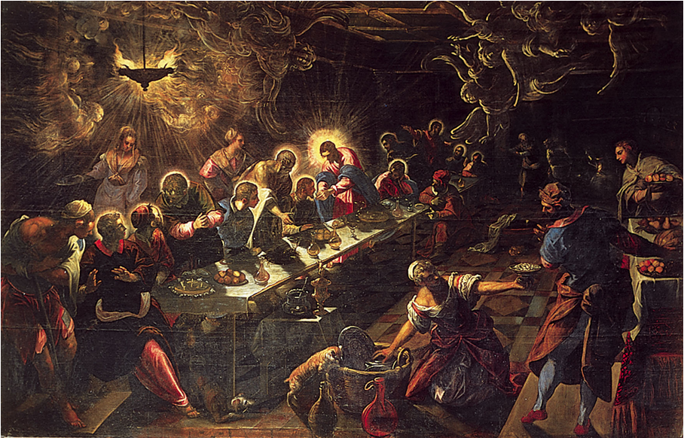

Why would the angels marvel at the work of God’s hands – the work of our salvation? The answer is clear. There are no “saved” angels because salvation is not for them, but for us. Jesus died to redeem fallen men and women, not the angels. They’ve never experienced new life, the new birth, regeneration, the indwelling of the Holy Spirit, or the wonder of deliverance from sin. That which we have experienced in Jesus Christ, the angels never knew and will never know. Only humans can be saved. Only humans can be redeemed. We alone of all the creatures in the universe can experience the wonders of God’s saving grace. And this has been the plan since before the ages of the ages.
You have been chosen to see and know the glory of God through the radiance of the Son by the power and presence of the Holy Spirit. You.
So let his light shine on you, and in you, and from you onto others, so that all may see God’s goodness going on in your life, and then along with you give glory to our Father who is in heaven. Amen.

